Use Case Specification:  Add to the event calendar

# Use-Case Name Add to the event calendar Brief Description

# *The primary actor in this case is a site administrator that is adding an upcoming event to the calendar.*

# Flow of Events

## Basic Flow

## *The user in this case will be able to select an “add event” option, where they will then be able to fill out a form including event name, time, date, and description.*

## Alternative Flows

### < First Alternative Flow >

#### < An Alternative Subflow >

### < Second Alternative Flow >

# Special Requirements

## < First Special Requirement >

# Pre-conditions

-Logged In system

- Create an event to be approved by the organization with detailed message

# Post-conditions

-Confirmation email of approved event and with any additional information

-The event will be posted

# Extension Points

## <Name of Extension Point>

Use Case Specification: Modify the event calendar

# Use-Case Name Modify the event calendar

# *The Primary actor in this case is a site administrator looking to edit info on a park event in the calendar*

# Flow of Events

## Basic Flow

## *The user in this case will select an event on the calendar and select an “edit info button” which will take them to a form showing the current information listed on the event, where they can edit and resubmit the form.*

## Alternative Flows

### < First Alternative Flow >

#### < An Alternative Subflow >

### < Second Alternative Flow >

# Special Requirements

## < First Special Requirement >

# Pre-conditions

-Logged In system

- Previously created event already approved and added to calendar

# Post-conditions

-Once button is clicked, a form will have to be filled out and sent to organizations email

-Organization will send out a confirmation email

-The event will be re-posted

# Extension Points

## <Name of Extension Point>

Use Case Specification: Delete the event on the calendar

# Use-Case Name Delete the event on the calendar

# *The Primary actor in this case is a site administrator that is looking to remove an event from the calendar that has either passed or has been postponed/canceled.*

# Flow of Events

## Basic Flow

## *The user in this case will select the event in question on the calendar and select a “delete” button that will automatically remove the event from the site calendar.*

## Alternative Flows

### < First Alternative Flow >

#### < An Alternative Subflow >

### < Second Alternative Flow >

# Special Requirements

## < First Special Requirement >

# Pre-conditions

-Logged In system

- Previously created event already approved and added to calendar

-Delete button has to be clicked first

# Post-conditions

-Once button is clicked, the event will automatically be removed from the website and an email will be sent to the organization

-Organization will send out a confirmation email

-The event will not be reposted

-If a mistake is made, an email must be sent to the organization

# Extension Points

## <Name of Extension Point>

Use Case Specification: Billing and Shipping Info

# Use-Case Name Receiving Shipping and Billing Information

## Brief Description

The Primary actor in this case is a user who has begun their checkout in the site storefront.

# Flow of Events

## Basic Flow

. The user in this case will enter their shipping address, and their payment information using the same safe and secure software as the donations page.

## Alternative Flows

### < First Alternative Flow >

#### < An Alternative Subflow >

### < Second Alternative Flow >

# Special Requirements

## < First Special Requirement >

# Pre-conditions

-Logged In system

-Items are added to shopping cart or bought out separately

-When ready to check out, shipping information and billing information is asked for

-Fill out respected boxes with correct information

# Post-conditions

-Option to have information saved will be available

-Option to have information updated will be available for future purchases

# Extension Points

## <Name of Extension Point>

Use Case Specification: Add to Suggestions

# Use-Case Name Receiving Shipping and Billing Information

## Brief Description

The Primary actor in this case is a user that wishes to see something more added to the Wilderness Louisville website.

# Flow of Events

## Basic Flow

The user in this case will select a button in the menu bar that says “Make a Suggestion” and can send a direct email or message to Wilderness Louisville officials.

## Alternative Flows

### < First Alternative Flow >

#### < An Alternative Subflow >

### < Second Alternative Flow >

# Special Requirements

## < First Special Requirement >

# Pre-conditions

-Logged In system or Anonymously leave a message

-Clicked on the menu bar on the button that says “Make a suggestion” or through the contact us portion of the website

-

# Post-conditions

-A confirmation email will be received upon submission

-A general automated response will be issued immediately followed up by a email detailing the basis of the message

# Extension Points

## <Name of Extension Point>

Use Case Specification: Ordering From Store

# Use-Case Name Ordering From the Store

## Brief Description

The primary actor in this case is a user who has decided they wish to buy an item from the store on the site.

# Flow of Events

## Basic Flow

The user in this case will enter their shipping address, and their payment information using the same safe and secure software as the donations page.

## Alternative Flows

### < First Alternative Flow >

#### < An Alternative Subflow >

### < Second Alternative Flow >

# Special Requirements

## < First Special Requirement >

# Pre-conditions

-Logged In system

-Items are added to shopping cart or bought out separately

# Post-conditions

-Confirmation email sent to user’s tied email address

-Items will be received immediately or shipped as soon as possible depending on the item

# Extension Points

## <Name of Extension Point>

Trace Matrix for the six use cases listed before. The diagram below shows the use case (on the left) and how it is responsible for handling the system requirements (at the top).

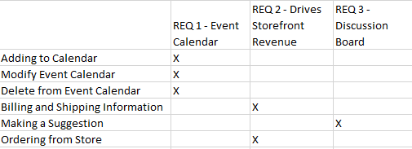

The admin will have most permissions associated with everything on the website. This is intentional because the admin should be able to moderate anything that they need to add, update, or delete and or undo from Wilderness Louisville. The user will have a more limited experience with accessing things.

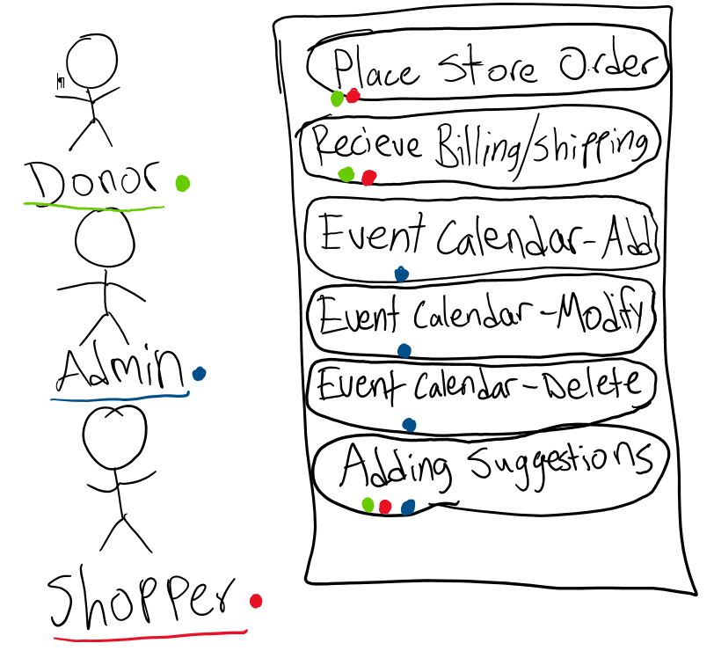

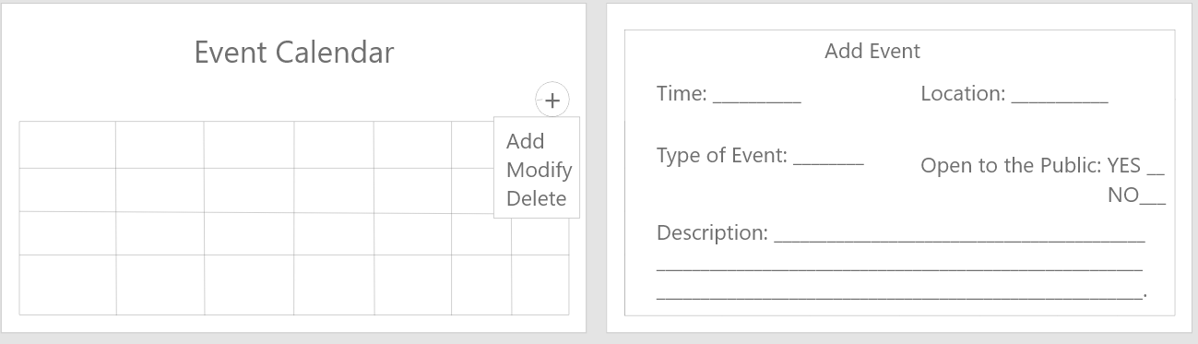

This will be how the user will be able to submit their request for a event to be added to the calendar

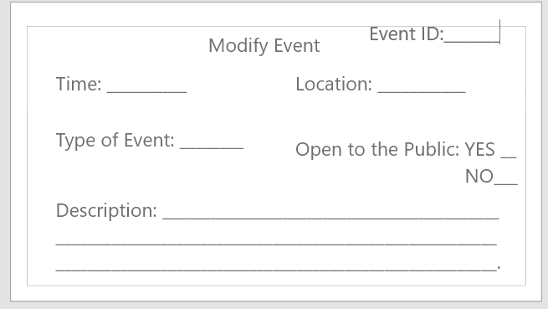

This will be how the user will be able to modify an already existing event on the calendar.

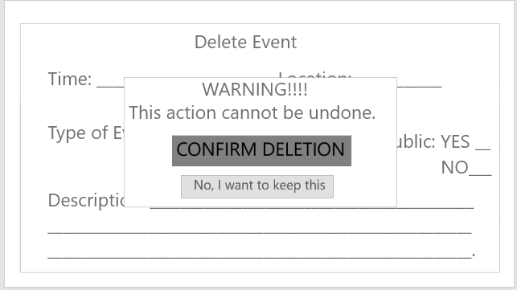

This will be how the user will be able to delete an event from the event calendar.

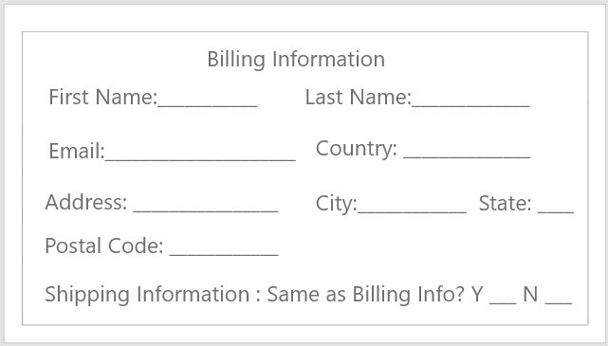

This will be how the user will enter their billing and shipping information to the system.

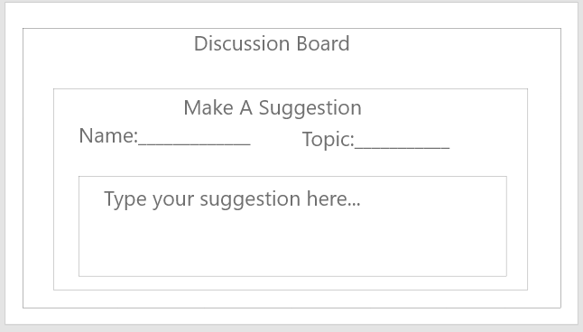

This will be how the user can submit a suggestion for the discussion board to the system.

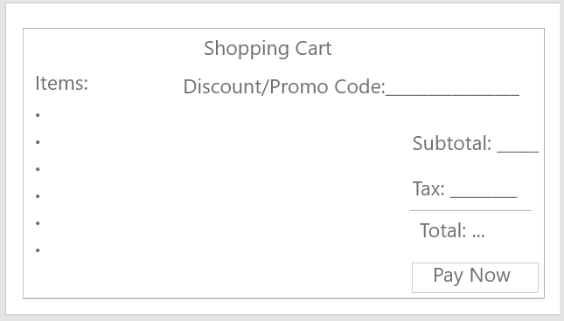

This will be how the user will check out his or her items in their shopping cart to the system.

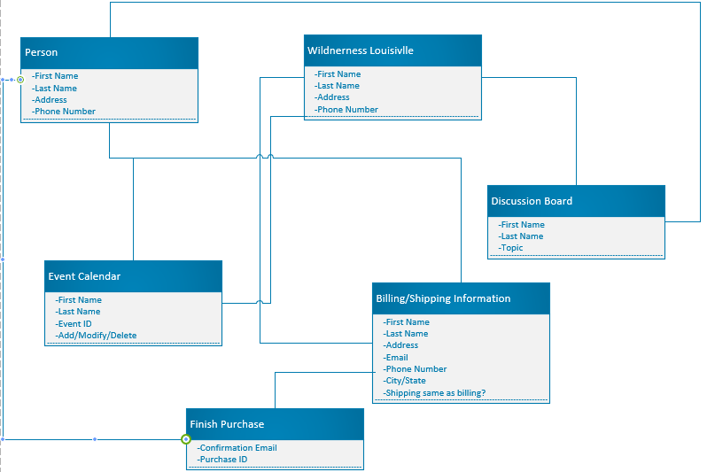

The diagram above shows the different interactions between the user and the website. Wilderness Louisville will be able to take this information and do a number of things. The person has unique characteristics for the system to tell one apart from another. The user can use this to add, modify and delete and event on the event calendar and Wilderness Louisville has administrative purposes and ties to this as well. With the discussion board, the user has the ability to submit a suggestion through putting in their first and last name and the topic of their suggestion, and again Wilderness Louisville has administrative purposes again. Billing and shipping information come into play when a user wants to buy something from the website and needs to supply their payment information. They have the option to enter their information once with the ‘shipping same as billing’ option, and again Wilderness Louisville has administrative controls. When the purchase is complete, the user will receive a confirmation email of the purchase and the purchase ID specific to every user’s purchase. The system will automatically keep a record of the purchases.

Sequence Diagram:

Adding to the Event Calendar

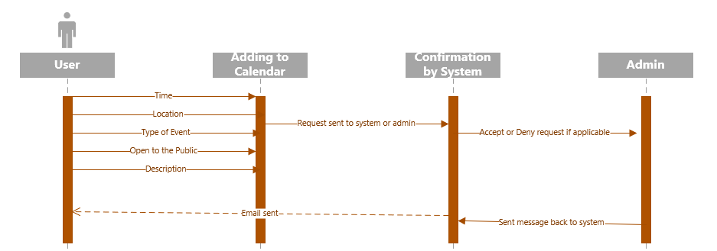

Modifying the Event Calendar

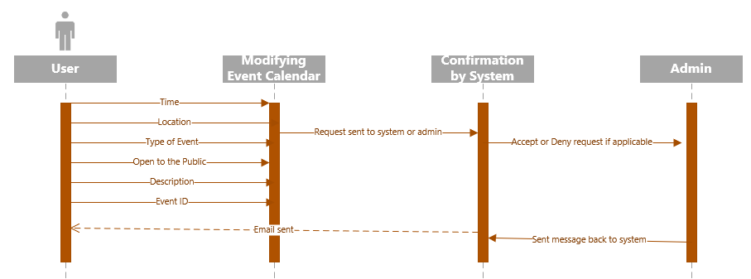

Deleting an event from the Event Calendar

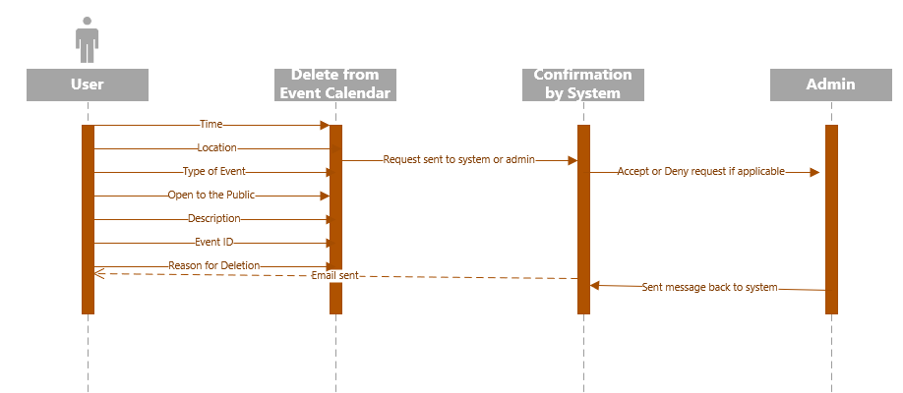

Billing and Shipping Information

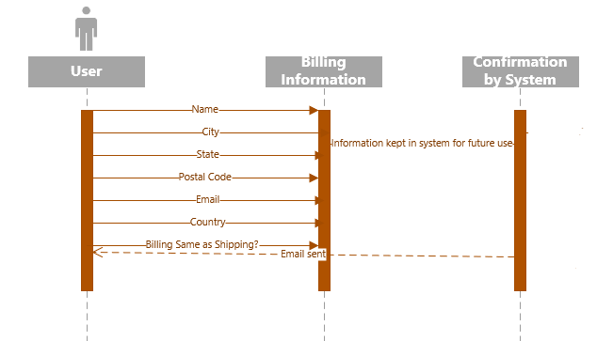

Making a Suggestion (Discussion Board)

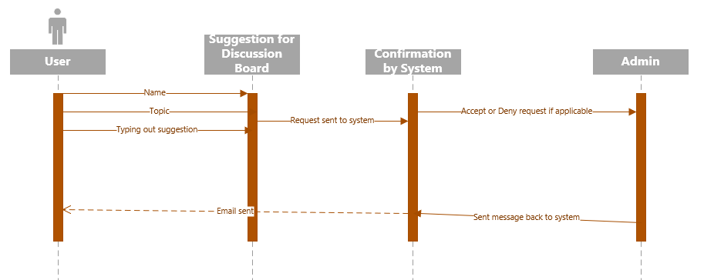

Ordering from Store

